Medical and HSC Library Document Supply Survey November 2012

Report

Introduction

  - The Medical and HSC Library carried out a survey of HSC users in October/November 2012 to obtain feedback on the document delivery service provided and to explore possibilities for future development including charging. The survey took the form of a web-based questionnaire the link to which was emailed to all HSC users.

  - The survey remained live for a 4-week period between 12 October and 12 November 2012.

  - The questionnaire is attached to this report as Appendix 2.

Respondent Profile

  - A total of 1094 responses were received which equates to 10% of our library members. Table 1 shows the response rate for each category of user. Some respondents commented that there was no option to cover their category and they have been assigned to Other.

Table 1: Category of user

Alternatives | Percent | Value
1 Administration/Clerical/Manager | 5.7 % | 62
2 Allied Health | 13.8 % | 151
3 Clinical Psychologist | 2.2 % | 24
4 Dental | 1.0 % | 11
5 Medical | 26.6 % | 291
6 Nurse/Midwife | 30.7 % | 336
7 Scientific/Technical/Pharmacy | 6.6 % | 72
8 Social Worker | 7.6 % | 83
9 Other | 5.9 % | 64
Total |  | 1094

2.2 Respondents were asked which library they normally used. The responses are summarised in Figure 1.

Figure 1: Libraries used

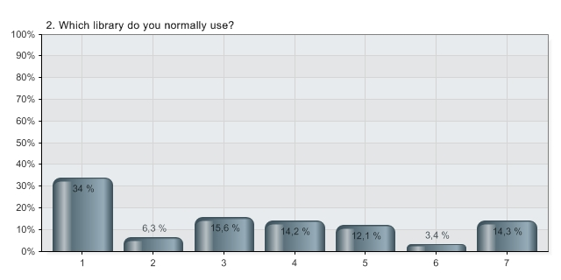
1 Medical Library (RVH)
2 Biomedical Library (BCH)
3 HSC Library Altnagelvin
4 HSC Library Antrim
5 HSC Library Craigavon
6 HSC Library Knockbracken
7 Other

Respondents were also asked which Trust they worked in and the breakdown is given in Figure 2 below. A number of respondents were not Trust-based; these responses have been included in BSO and Other.
Figure 2: Home Trust

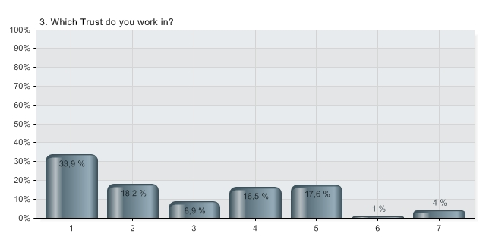
1 Belfast Trust
2 Northern Trust
3 South East Trust
4 Southern Trust
5 Western Trust
6 NI Ambulance Service
7 BSO and Other
  - It was pleasing to note that most respondents, 77%, had requested material from the library
although 23% had not. Of those who had submitted requests the number of items requested
in a year are shown in Figure 3.
Figure 3: Number of items requested

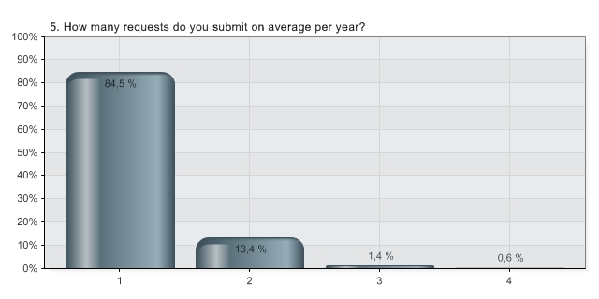
1 Less than 10
2 10 - 29
3 30 - 49
4 Over 50

Aspects of the Document Supply Service

The next section of the questionnaire sought to establish how our members used the document supply service and their satisfaction with it.

3.1 Respondents were asked if they preferred to submit requests online or by using printed forms. As can be seen from the results in Table 2 below, a clear majority prefer to submit requests online. This is a noticeable shift from the response to the general user survey carried out in January 2011 when only 32% of users said they preferred to request material online.

Table 2: Preferred method of requesting material

Prefer online | Percent | Value
1 Yes | 58.1 % | 634
2 No | 8.6 % | 94
3 No preference | 22.4 % | 244
4 Not applicable | 10.9 % | 119
Total |  | 1091

3.2 The next two questions sought to establish whether respondents requested material by using the Place Request option and/or directly from database searches using honniConnect. The results shown in Table 3 below indicate that there is a need to promote these services as the majority of our users do not avail themselves of the facilities provided.

Table 3: Method of placing

requests

Alternatives | Requested via ‘Place Request’ | Requested via ‘honniConnect’
1 Yes | 34.2 % (370) | 33.6 % (365)
2 No | 65.8 % (712) | 66.4 % (721)
Total | 1082 | 1086

  - Respondents were then asked how satisfied they were with the provision of inter-library loan requests delivered by Secure Electronic Delivery (SED) to their desktop. A significant number of users said they had not received anything by SED. This reflects the problems we are having delivering documents by SED to HSC staff in the workplace . Articles from the British Library can be delivered direct to users’ email via SED provided the PC being used has a small Adobe Reader plug-in called FileOpen. Although the plug-in is easily installed it is generally not available on Trust PCs and it has to be reinstalled after every Adobe Reader update. This can make it difficult for users to avail of the SED service from work.

Figure 4: SED

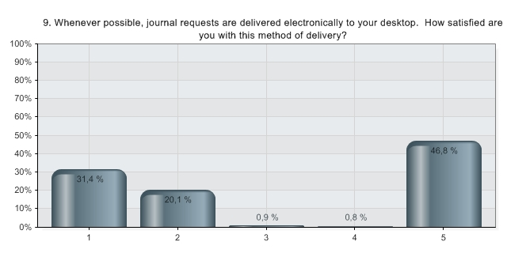
1 Very satisfied
2 Satisfied
3 Dissatisfied
4 Very dissatisfied
5 I haven’t received anything via Secure Electronic Delivery

3.4 In the final question in this section users were asked which aspects of the document supply service were most important to them. The results are shown below. The aspects of the service mentioned in the Other category included accessibility, ease of use, range of documents available through the service, ability to charge to an account rather than having to pay personally. Library staff input is still considered highly important as, not surprisingly, is speed of service.

Figure 5: Aspects of the service

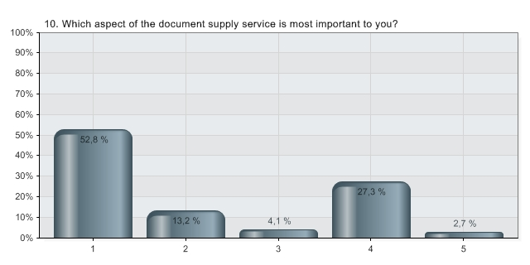
1 Helpful/knowledgeable staff
2 Online submission of requests
3 SED – Secure Electronic Delivery of articles
4 Speed of service
5 Other

Gathering Information

The penultimate section of the questionnaire sought to establish where users found out about the material they requested via the Document Supply Service.

4.1 58% of users located material via the honni catalogue with a significant number of others acquiring references from databases or bibliographies. Sources mentioned in the Other category included Google and Google Scholar, Amazon, current awareness services, library staff, professional organisations such as the King’s Fund, CBT Forum, Scottish Forensic Network, NELM and the Family Nurse Partnership, cutting edge collaborations and word of mouth.

Figure 6: Reference sources

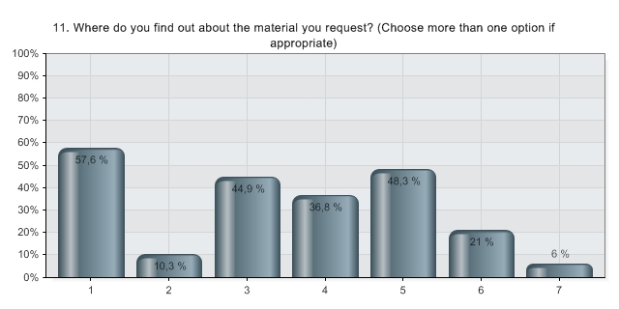
1 honni Library Catalogue
2 Other libraries’ catalogues
3 Databases
4 Course reading lists
5 Cited references – in a book or article
6 Personal recommendation
7 Other
4.2 The second question in this section related to obtaining full text articles that were not available via honni. The vast majority, as shown in Figure 6 below, were retrieved either from a professional association or via open access. Sources of full text articles listed under the Other category included Queen’s University, professional or work-based libraries, the authors, personal journal subscriptions and the Health-ill list.

Figure 7: Sources for full text articles

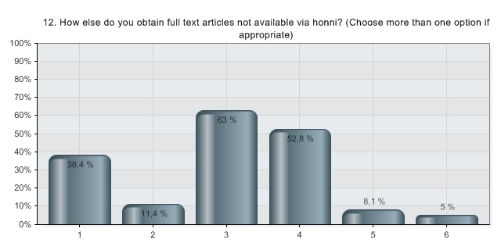
1 From another colleague
2 Purchased direct as pay per view (from a publisher)
3 Online free / open access
4 Via a professional association / society / college
5 Have never used any other sources to obtain material
6 Other

Future Services

The final section of the questionnaire covered future developments. It was pointed out that the majority of requests were satisfied from the existing network of HSC and Queen’s University Libraries but some material had to be requested on inter-library loan usually from the British Library. The current cost of items requested in this way is significant:

 | £
Book | 14.10
Book renewal (after 1st 4 weeks) | 4.30
Journal article (print) | 10.45
Journal article (SED - electronic direct to desktop) | 8.95 | + VAT
Urgent item | 16.00
Urgent item (if required within 2 hours) | 25.00

5.1 Respondents were asked if they, or their Trust, would be willing to pay for this service and were given three options:
i. Pay for the document supply service.
ii. Pay for the inter-library loan (ILL) service if all documents held in Queen’s or HSC Libraries were provided free of charge (current cost 50p per item).
iii. Do without the ILL service.

Unsurprisingly, the majority of respondents said they would not be willing to pay but a significant number, 34%, said they would be prepared to pay for inter-library loan material provided items available locally from the QUB/HSC network were free.

The responses are shown in Table 4 below.
Table 4: Payment options

Alternatives | Percent | Value
- I/my Trust would be willing to pay for this external services | 15.4 % | 154
- I/my Trust would be willing to pay if there was no charge for material supplied from within the Queen’s Medical and Healthcare Library network | 33.9 % | 339
- I/my Trust would not be willing to pay for the service and will do without it | 50.7 % | 506
Total |  | 999

5.2 The final question attempted to ascertain what respondents felt would be a fair price to charge for the ILL element of the Document Supply Service. 45% felt that £6 per item would be acceptable, with only 12% being prepared to pay £8-£10 and 43% voting for £6 or less. Others commented that the price they would be prepared to pay would depend on such factors as need, size and cost relative to purchase price.
Figure 8: Charges

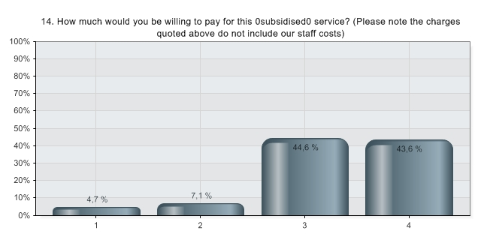
1 £10 per item
2 £8 per item
3 £6 per item
4 Other amount

  - Representative comments.

Over 300 comments were received on all aspects of the Document Delivery Service with the majority being very positive about the current service but also many indicating serious concern about the proposal to charge in future. It was also clear from the comments that there is a lack of understanding of copyright legislation and of the licensing arrangements which enable HSC users to access electronic resources.

All individuals who provided comments on the service were contacted. A representative sample of comments grouped under key topics are listed in Appendix 1.

6. Executive summary and recommendations

The Document Delivery Survey has proved to be a very worthwhile exercise. It attracted an excellent response with numerous comments and served the dual purpose of raising user awareness of the existing service and its associated costs, and of providing library staff with guidance on future developments. The key purpose of the survey was to gather information on how the current service is used, obtain feedback on issues of concern and test the water in regard to future charges.

Generally, the responses indicated a high level of satisfaction with the current service and an appreciation of the knowledgeability and helpfulness of library staff. There was clear evidence, however, that many users did not understand the impact of copyright legislation and licensing restrictions on the downloading and copying of documents. There also appeared to be an erroneous assumption that everything on the internet is free or that Athens authentication would somehow enable such free access. There is undoubtedly a need to market the document delivery service,to provide training in its use and to clarify issues relating to the availability of full text material online. Many of the critical comments related to speed of access or to problems using the secure electronic delivery (SED) method of opening documents from Trust computers.

In the response to the survey considerable concern was expressed that charging would have a negative impact on patient care and on continuing professional development. Not surprisingly library users want easy access to material or, failing that, to online requesting with quick delivery at low cost. There was, however, a realisation that the current subsidy of inter-library loan material was not sustainable. Indeed many respondents noted that they had been quite unaware of the high cost incurred by the Library in getting material from outside the Queen’s and HSC network and in particular from the British Library. A reasonable number of respondents, however, felt that a charge in the region of £6-£8 would be acceptable although most of them felt that the cost should be borne by the employer not the employee.

It is clear from the results of the survey, therefore, that it is important to communicate the message that the current charge of 50p per item is not sustainable but that every attempt will be made to mitigate the effect of the significant increase. There is a need to engage with all Trusts at a high level to explore how a charging mechanism might work fairly and efficiently and to ensure equity of access across all Trusts and all professions.

In summary the Library staff need to discuss the way forward with key personnel, finalise methods of payment, review resources to achieve value for money, endeavour to surmount ICT barriers to increase ease of access to SED documents, improve access to material held throughout the network of Queen’s University and HSC libraries thereby reducing the need to apply elsewhere for material, and provide information and training on using the document delivery service.
Recommendations
The recommendations resulting from the survey are as follows:
6.1 Produce a communications plan to ensure all key personnel including Chief Executives, Directors of Finance, Corporate Management Teams,Trust Boards and library members are informed about the proposed introduction of charges and the reasons for the increase.
6.2 Investigate methods of payment.
6.3 Move towards greater provision of online material.
6.4 Ensure books from all outlier libraries are available to Medical and HSC libraries.
6.5 Investigate alternatives to the British Library.
6.6 Implement agreed charges from 1st September 2013.
6.7 Audit requests for material not held in stock and consider purchasing books or taking out journal subscriptions if better value.
6.8 Plan additional training to promote the library service and ensure users are familiar with the new procedures.
6.9 Provide a guide to the document delivery service which explains how to submit requests, renew loans, obtain feedback on progress of requests, and what limitations are imposed by copyright legislation and licensing restrictions.
6.10 Publicise the service.
6.11 Existing vouchers to be honoured for a period after new system is introduced.

Appendix 1 Representative Comments

General comments
Service too complicated and not easy to use.
Increase speed.
Belfast Trust hasn't installed the software needed to view reprints. Get them to keep it up to date.
More awareness sessions - most staff don’t know anything about it.
Further updates on how to access the service particularly to those not using it frequently or who are not good with computers.
I would like to make a comment about your data collection instrument. The questionnaire should have had more free text options as you have not always covered all the responses e.g. I do not work for any of the HSC organisations listed but had to indicate one on the list to proceed. I work for the Public Health Agency. I had to answer a number of questions falsely just to be able to move through the questionnaire. I am sure that I am not the only person affected and therefore the reliability of the responses could be called into question.
Might be useful if the staff could advise which articles will be of most relevance to purpose of request if payment is being made. This obviously requires knowledgeable staff.
The personal assistance of staff in the Library and their vast experience and knowledge is invaluable and I cannot envisage an alternative way in which that service could be improved.
It is an excellent service and I cannot do my work without it. The staff in our library are first class and an absolute pleasure to work with.
Very useful and efficient service already, online requesting very user friendly.
I do not like the idea being alluded to in this questionnaire that clinicians may have to seek funding for books or articles. Living in a large city it may be easy to access book or articles by going to the library, however I work in Enniskillen and Omagh and cannot go to a local academic library thus the library service of sending out book and articles is vital to our services if they are to continue to get up to date books and articles. my sense is that Trusts will not pay for this service thus leaving clinicians at a loss if this service is taken away or is costed to the clinicians/staff. to take it away would be unfair and an unhelpful cost saving exercise that would leave rural clinicians at a severe disadvantage.
Have a very friendly, helpful and efficient service currently. No change required
Regular education sessions.
I have had no problems with the document delivery service. I do not have the funding to pay extra beyond my professional registration fees for further reading. I would have to use their resources.
More training on use of Honni.
Very impressed with speed of service
Keep up the good standards.
It is a very good service and I appreciate every bit of it.
Further updates on how to access the service particularly to those not using it frequently or who are not good with computers.
As I work in western trust I can't pay personally for material borrowed via honni site. I have a bill outstanding at present and I will have to wait to I get to Belfast to pay for this. However I am glad that the library is not pushing for this payment. Keep up the good work.
Book requests to arrive quicker.
Sending by internal mail to work place is ok.
It may be worth checking the materials that have been requested outside of the current service provision and the frequency of such requests and add these to the current library of materials which would mean that only rare exceptions need to be catered for. Whilst I couldn't answer all the areas I feel that I am currently undertaking a 3 year course and will be accessing the honni services much more. To date they have been exceptional and have always delivered whatever material I have requested.
My employer is actually the PHA which was not listed as an option on this questionnaire.
The PHA and HSCB should both have been listed.
Find the librarians so helpful and very efficient therefore at key points in the year prefer to visit the library as this is quicker for me than going online.
Current service appears good.
Really concerned that we might lose this valuable service, especially for those of us working directly with NHS patients - I feel it will affect the quality of service that we offer. I don’t feel that it is acceptable - and the issues of funding should be addressed again - The Dept. of Health should be adequately funding the access to resources to allow patient care to evidence based and up to date - access to journals/books is an essential part of this.
Great service at present. I hope funding issues do not take this service away.
I use the Royal Society of Medicine library. It is available to me online and I can order articles via the telephone. There is sometimes a small charge for this.
I'm an infrequent user of the library, but find the staff to be most helpful. The updated HONNI system seems to be a great improvement
Knowledgeable and helpful staff are essential.
It is very important for me as a clinical scientist to have access to British Library resources for articles and documents not available locally
Need better communication about how to access web based information.
Need to ensure people living at a distance from libraries are not disadvantaged.
I wish to highlight that library staff are very helpful and there assistance is of great benefit.
I think that this service could be used without much thought and when not completely necessary, without realising the full cost. It is a great service to be able to avail of, but should be restricted at this time of cut backs.
Simple, clear and user friendly. as a social worker I find it hard to access uptodate information and would love someone to assist me set up my account. many thanks.
I feel strongly that the subsidy should remain. Having access to cost effective knowledge ultimately helps clients. If the prices are increased this may mean staff no longer access this material as it is too costly.
It is absolutely first class and should be protected at all cost!
I find it an invaluable means of keeping up to date with research within my field, particularly in regard to patient treatment.
Any time I have used the service it’s been grand. I got the paper I wanted usually within a usable timeframe of a few days. Does exactly what I expect. Spot on
All nurses in the Northern Trust should automatically be registered with Honni as soon as they are employed with the Trust to support research and development within their role.
Library staff are always friendly, knowledgeable and helpful.
There is some overlap between QCat and Honni - I am currently seconded to QUB from BHSCT so I also have access via QCat although I find HONNI have a better selection of journal articles in my field. Perhaps these resources could be joined up?
Communications dept. in the Trust would need to be contacted to inform of the Trust's stance on the cost of borrowing materials supplied outside of the QUB/HSC library: otherwise it is down to the individuals to carry the cost. This would be rather hefty if undertaking a course and this info is needed; however the support/commitment may vary from different directorates and may need to be discussed on a case by case basis.

User friendliness of service
Since the Honni system has changes it is much more difficult to use. I have found it very difficult to obtain access to online articles.
I have recently used the service, and whilst I struggled with changes to how the system operates initially, I found staff to be extremely helpful.
The Honni service has problems at times and quick repair of the service would be appreciated.
I find the new website tricky to use so far. I will persevere however I plan to book a session with a member of Library staff to check if I am using the system most effectively.
The new HONNI isn’t just as easy to use as the older version (or maybe I’m just getting old!).

Online requesting
A tracking system online to see when article expected/posted.
Occasionally articles details do not transfer into the request form and doing this manually is slow.
When ordering journals the icon to have it delivered electronically is not very obvious so I ended up getting some posted in error and unfortunately this took too long.
Guaranteed electronic arrival date.
Track request to see what stage it is at.
I'd like to be able to choose "email me and I’ll come and collect it" as an option.
Apart from desktop journal requests which are slow all else excellent service.
Library staff have been very helpful when the electronic delivery or software has gone array.

SED issues
In the past I have had trouble opening journal articles in my Trust email account, which has deterred me from continuing to request this particular aspect of the library service: I have been requesting paper copies for this reason.
Ability to use SED within Trust ICT networks.
I have occasionally experienced problems opening the secure file. It will be helpful if this can be improved.
Improved access to secure online delivery.
In Craigavon hospital where I work it is not possible to open electronic articles that I have ordered on the hospital library computers. This is most inconvenient especially since I do not have a printer at home. Surely if you order an article from the library in Craigavon you should be able to open it on receipt.
Trust should implement the document opening software on Trust computers - I currently do this at home!
Would be good to be able to access/open the journals/articles that are emailed using my work email/computer instead of my private/home computer, so it could be reviewed/ printed in work!
I would be better if Trust IT provision could allow for the electronic delivery through trust email services. I have had to receive emailed articles in my private Hotmail address because of trust email filters. I generally think that the service works well and I am pleased with it.

Payment issues
Payment- it's difficult to pay 50p when the borrower isn't actually 'on site'- could there be any other methods of payment?
Paying bills if not on site can be delayed or forgotten, perhaps pay up front for charges more than two pounds or deductions taken from salaries and wages directly may help this.
It would be beneficial if a medicines information unit could be set up to order online, with a med info account, we have discussed this, but apparently it is difficult to do.

Trust network issues
In SWAH unable to access QUB web site
Belfast Trust hasn't installed the software needed to view reprints. Get them to keep it up to date.

Copyright and Licensing
If payment for articles will no longer be subsidised, the strict security settings of the PDFs supplied should to be eased. Specifically allowing them to be read via devices such as the IPad. Current they are time limited access with only the possibility of printing via a desktop.
I one copy was bought could it not be photocopied and shared.
Articles that are available online should not have to be ordered. They should be freely available
Probably in this internet age we should be able to access most articles via the web.
There is some overlap between QCat and Honni - I am currently seconded to QUB from BHSCT so I also have access via QCat although I find HONNI have a better selection of journal articles in my field. Perhaps these resources could be joined up?

Increasd access to e-books
More material eg e- books on line.
More e-books would be useful as well, although this may just take time until old books are scanned (any plans?) and more new e-books come into the system as pdf/epub/mobi.

Increased access to e-journals
Many articles listed for example on a Medline search through honni are not available through honni connect. This greatly restricts the usefulness of honni and leads to an increased number of requests for articles.
Extend online free access.
Articles that are available online should not have to be ordered. They should be freely available.
Probably in this internet age we should be able to access most articles via the web.
Free online access for all members working in the Health and Social Care Service.
More availability to online journals, although there is already quite an extensive range online.
HSC users would really need an extended choice of journals available on line similar to what is available to QUB users.
More electronic articles and read online with no print charge.
Athens subscription could be expanded. If enough requests are made for articles from a specific journal it would be more cost effective to obtain subscription for the journal rather than making per article requests via the BL. the specific journal I can think of that is relevant to me is Plastic and Reconstructive Surgery via OvidSP.
Journal proposals
I joined recently and I am disappointed, that a major Journal, british, of my Speciality is not available online. (BJA). Maybe I am not clever enough to access it, but bypassing HONNI and go to www is often better/faster/easier.
Annual subscription to "plastic and reconstructive surgery" would significantly decrease the annual cost of requested articles from within our department
Getting ScienceDirect or Athens will be good (may be too expensive)
Athens subscription could be expanded. If enough requests are made for articles from a specific journal it would be more cost effective to obtain subscription for the journal rather than making per article requests via the BL. the specific journal I can think of that is relevant to me is Plastic and Reconstructive Surery via OvidSP.
Don't lose subscription to uptodate! Access to NEJM and lancet is essential - thank you!
i would be grateful if you would consider getting Journal of Clinical Endocrinology and metabolism available via HONNI.Otherwise I have no issues with the service. Staff have always been very helpful and tried to accomodate. The new HONNI isnt just as easy to use as the older version (or maybe Im just getting old!)
Thought the 'uptodate' service was very good.
If the library subscribed to the jbjs America and a few of the more popular orthopaedic journals eg knee, journal of hand surgery that would be useful.
Please subscribe to Plastic and Reconstructive Surgery Journal (PRS) online. It is the most authentic and widely used source of evidence in the field of Plastic surgery. The burns unit in RVH held subscription for years but now it has been stopped for a few years. Please reinstate it.
Increase number of online journals available. Neurosurgery has very few on shelves and JNS/neurosurgery/acta are not available through HONNI

Cost
I feel this service should be paid for centrally by government so that professionals can get on with their job instead of having to seek funding for every article or book that may be required.
Would really reduce what you would have access to, even 50p adds up after a while.
It would be a personal payment and I could not afford to do this on a regular basis.
I find the cost for online delivery service to be surprisingly high and was unaware that this was the case. It should be cheaper to request an e version of a document. Perhaps it would be useful to audit what has been requested over the last three years and refine the service based on this.
I think it is a very good service, however I was not aware of the huge costs. I doubt that the Trust would pay for articles to be ordered unless it was part of the research department. Many thanks.
This will be a big loss for anyone completing a research degree, writing papers, etc. Quality and quantity of research publications and presentations emanating from NI will undoubtedly drop significantly. What a shame.
I find it incredible that medical staff have to pay for articles required for direct patient care.
Free online access for all members working in the Health and Social Care Service.
Costings need to be agreed so staff know what is covered and what is not
Set up a standing order with each department to cover some of the costs and bring prices down.
Really concerned that we might lose this valuable service, especially for those of us working directly with NHS patients - I feel it will affect the quality of service that we offer. I don’t feel that it is acceptable - and the issues of funding should be addressed again - The Dept. of health should be adequately funding the access to resources to allow patient care to evidence based and up to date - access to journals/books is an essential part of this.
I can understand why charging is needed but it may make it difficult for managers to access materials as the funding will all end up going to clinical staff but it is still important for management to access academic articles etc. so that we too can improve our services and become world class.
If the library is covering the major titles then it may be the case that individuals will have to incur the cost for accessing more obscure material, or the library increases the amount of links to other facilities/libraries etc. that store these documents.
Increasing costs would have a direct impact on what I could request.
I had no idea how HORRENDOUSLY expensive your costs are. I have generally avoided sending for articles unless absolutely necessary - doubly so now! Nevertheless, the provision of a service of this sort is surely necessary in modern times, and other service users probably have a greater need for it than me.
I think the costs identified will penalise professionals who are required to keep up to date in their practice.
When I am researching something it is me, not the trust who pays for articles and photocopying etc. I simply wouldn't be able to afford the proposed charges for books or articles from the British library.
If request is for the benefit of patient care then the Trust should pay. If it is to help with writing medical reports then the charges should be passed on to whoever requested the report i.e. solicitor firm.
I have always found the library service to be very efficient and the librarians to be extremely helpful. I also think that there is a need for good relationships between university libraries and hospitals and I appreciate that libraries have increasing costs. However, I worry that the introduction of increased charging for book/article request would not be meet by my employer: if I had to pay for these requests myself, it would probably decrease my use of the library. It might be helpful to consult with heads of department in hospitals/budget managers, to determine if they would fund these proposed increased borrowing costs for staff
Currently use the 50p system and would like to be alerted when ordering online the cost of the article.
Would an annual subscription be better than a charge per item?
I was a post-graduate student and used the HONNI site and request service extensively last academic year. The service was superb and my requests were all delivered without any problems. If an increased cost was included for the staff to meet then I would be reluctant to use the service in the future.
Trust probably go without as they don't know what privileges are available with HONNI/QUB membership. Perhaps an initiative in conjunction with the DHSS/Trusts to make more people aware of what is possible/achievable?
The cost is big concern. Good quality information on health is already expensive and inaccessible enough. A lot of my writing involves making reviews and summaries of information freely available for others. If there was too big a cost, it would reduce access and readership, thus further promoting ignorance, instead of knowledge.
There is an ongoing movement within the Belfast Trust to make staff pay for to do certain aspects of their job (eg request chart for audit £1.79 per chart, and to create a large barrier of admin to get funding for educational activities) This has the effect of stifling good working practices, rather than encouraging them. As of late there has been quite a cull of journals available to health staff even of staple ones like the drugs an therapeutics bulletin. I would estimate the requirement for article requests will increase, and a charge of £8 per article would influence some staff to contain their evidence.
I think that this service could be used without much thought and when not completely necessary, without realising the full cost. It is a great service to be able to avail of, but should be restricted at this time of cut backs.
Additional costs for articles will be a barrier to research and ensuring evidence based treatments.
If it became too expensive, then it won't be used which would be a shame and a disservice to our patients.
It’s very good for low cost.
It should be free to permanent HSC staff.
As a rural clinician the service is invaluable. I would suggest no change and to do so is putting rural clinicians at a severe disadvantage.
Professional staff are unfortunately easily dissuaded from study for PD, these suggested changes will undoubtedly have an impact.
I feel strongly that the subsidy should remain. Having access to cost effective knowledge ultimately helps clients. If the prices are increased this may mean staff no longer access this material as it is too costly.
I had no idea that this cost so much so thank you for bringing these charges to my attention.
Staff are being asked to attend masters modules in order to reach KSF gateways. There should be no cost to staff accessing books/articles esp. if on reading list. Tutors/lecturers running courses have to be told NOT to include references if they are not available at local libraries/databases for free.
I think the Trust should contribute to the cost of the loans as their service is benefitting from the studies completed by their staff, usually at their own cost.
In terms of the costs on the previous pages - this would need some consideration from the Trust as requests are related to work eg service development or studying.
Paying bills if not on site can be delayed or forgotten, perhaps pay up front for charges more than two pounds or deductions taken from salaries and wages directly may help this.
Proposed costs are too high.
I feel that it is an excellent service and have really benefitted from its availability, but appreciate that it is coming under increasing financial pressure, like every dept. in the trust. I feel as an allied health professional we are much less likely to get funding for library requests compared to medical staff.
I work in a rural area of the western trust and have always found it difficult to visit any of the libraries thus access to online facilities are a godsend. I would be very disappointed if charges are introduced to borrow from British library as I feel this is an essential facility in order that I may deliver a high standard of evidence based care. Please directly take these proposed charges to the trusts. They need to help subsides/cover the cost of these expenses.
£12 could be expensive for a book loan - might be cheaper to purchase the book yourself.
In the economic climate at present I would find it difficult to ask staff to help subsidise this service which in turn may alienate certain staff
If it is too expensive it will mean that we will limit our literature searches which could reduce the quality of the service offered.
Rather than pay to have a book photocopied/delivered I would probably purchase it myself or do without it.
Additional costs for articles will be a barrier to research and ensuring evidence based treatments.
In terms of the costs on the previous pages - this would need some consideration from the Trust as requests are related to work e.g. service development or studying.
Appendix 2: The Document Supply Questionnaire

QUB Medical & HSC Library
Document Supply Survey 2012
Please take a few minutes to complete this document supply survey. We would really appreciate your feedback on the service.
The Queen's Medical and HSC Library provides books and articles to HSC staff from within the regional network of university and healthcare libraries. We try to ensure that most of the resources you need are available locally. No library, however, can purchase everything relevant to a wide range of users' needs and there will always be a requirement to borrow material for you from further afield. Material not held in any of our libraries is obtained from the British Library and other major libraries. This is an increasingly expensive service and we need, therefore, to find out how well the current service is meeting your needs and what value you place on its development. Your answers will help to give us an indication as to how we could develop the service in future.
Thank you.

ABOUT YOU
1) * Please indicate your profession
Administration/Clerical/Manager
Allied Health
Clinical Psychologist
Dental
Medical
Nurse/Midwife
Scientific/Technical/Pharmacy
Social Worker
Other
2) Which library do you normally use?
Medical Library (RVH)
Biomedical Library (BCH)
HSC Library Altnagelvin
HSC Library Antrim
HSC Library Craigavon
HSC Library Knockbracken
Other

3) * Which Trust do you work in?
Belfast
Northern
South Eastern
Southern
Western
BSO (Business Services Organisation)

4) Have you ever requested a book or an article from the library?
Yes No (Go to question 6)

5) How many requests do you submit on average per year?
Less than 10
Between 10 and 29
Between 30 and 49
Over 50
THE SERVICE
Online requesting versus paper forms
6) Do you find submitting requests online more convenient than handling printed forms?
Yes
No
No preference
Not applicable

Online requesting via honni
7) Have you requested a book or an article using the 'Place Request' option on honni?
Yes
No

Online requesting via honniConnect
8) Have you requested books or journal articles direct from your database search results using honniConnect?
Yes
No

SED - Secure Electronic Delivery
9) Whenever possible, journal requests are delivered electronically to your desktop. How satisfied are you with this method of delivery?
Very satisfied
Satisfied
Dissatisfied
Very dissatisfied
I haven't received anything via Secure Electronic Delivery

What's important?
10) Which aspect of the document supply service is most important to you?
Helpful/knowledgeable staff
Online submission of requests
SED - Secure Electronic Delivery of articles
Speed of service
Other, please specify

GATHERING INFORMATION

Your requests
11) Where do you find out about the material you request? (Choose more than one option if appropriate)
honni Library Catalogue
Other libraries' catalogues
Databases
Course reading list
Cited references - in a book or article
Personal recommendation
Other, please specify

Alternatives to requesting material via the library
12) How else do you obtain full text articles not available via honni? (Choose more than one option if appropriate)
From another colleague
Purchased direct as pay per view (from a publisher)
Online free / open access
Via a professional association / society / college
Have never used any other sources to obtain material
Other, please specify
FUTURE SERVICES

The cost facts
Although the majority of requests are satisfied from within our own wide network or regional libraries at a cost to you of 50p per article, we regularly have to borrow material for you from other libraries, usually the British Library. This is an expensive service and at a time of severe funding pressures is no longer sustainable at such a nominal charge.
The current costs of requesting an item from outside our network are:
Book | £14.10
Book renewal (after 1st 4 weeks) | £4.30
Journal article (print) | £10.45
Journal article (SED - electronic direct to desktop) | £8.95 + VAT
Urgent item | £16.00
Urgent item (if required within 2 hours) | £25.00

13) Would you or your Trust be willing to pay to have a book or an article not held in HSC or Queen's libraries borrowed or photocopied for you and delivered to you?
I/my Trust would be willing to pay for this external service
I/my Trust would be willing to pay if there was no charge for material supplied from within the Queen's Medical and Healthcare Library network
I/my Trust would not be willing to pay for the service and will do without it

14) How much would you be willing to pay for this subsidised service? (Please note the charges quoted above do not include our staff costs)
£10 per item
£8 per item
£6 per item
Other amount

15) Please specify any ways in which you think that the document delivery service could be improved.

16) Any other comments on any aspect of the service or proposed changes?

© Copyright www.questback.com. All Rights Reserved.

