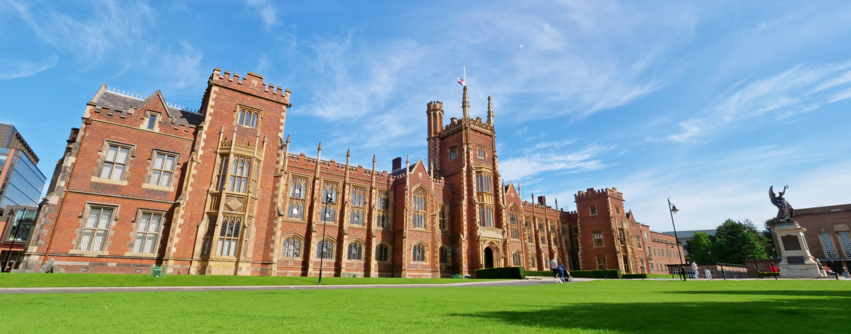

**‘The Loong’s Land – My China Story’**

**2024 UK University Student Short Video Competition Registration Form**

**基础信息**

**Basic Information**

请仔细阅读报名章程后，完整填写报名基础信息。所填写信息（非个人信息）将在入围、评选、结果公布、获奖作品手册制作等各工作环节及相关的信息公开中采用，如有信息错漏，责任由报名方承担。

Please read carefully the instructions and provide complete information for submission. The information provided will be used during the whole process of the contest, such as selection, evaluation, announcement of the results. All the information of works will be released online and on the results handbook, except for personal information. The applicants are supposed to take the responsibility for providing any incorrect or incomplete information.

1. 联系人姓名 Name of Contact Person *
2. 联系人电话 Phone Number*
3. 联系人邮箱 Email*
4. 作品中文名称 Title of Works (in Chinese)*

示例：《XXXXX》（作品名称需加书名号）E.g. 《XXXXX》

5. 作品英文名称 Title of Works (in English)*

示例：《XXXXX》（作品名称需加书名号）E.g. 《XXXXX》

6. 作品时长 Duration of Works*

每部作品不得超过10分钟 Each work is within 10 minutes.

7. 作品语种（作品语言不限，接收所有语种作品参赛）

Language of Works*（No requirements for the language used in the videos.）

1. 作品是否包含中英字幕 Does your video have Chinese and English subtitles?*
2. 团队所在地 Team Origin*
3. 作品拍摄地区 Location of Filming*
4. 作品涉及外籍人士所在的国家 Nationality envoled in your crew (Except Chinese)

**作品简介 Work Description**

以下内容需仔细填写，相关材料缺项或信息不完整，则不具备报名资格。

The following content must be filled out meticulously. If the information or the related materials are incomplete, the applicants will be disqualified.

1. 主创团队（中文名）Produced by (Chinese Names)*

不超过6人，人名用中文模式下顿号分隔开

Up to 6 people, whose names are separated by “、” in Chinese format.

2. 主创团队（英文名） Produced by (English Names)*

不超过6人，人名用英文模式下逗号分隔开

Up to 6 people, names separated by “,” in English format.

3. 获奖证书信息 Information on Award Certificate *

选择主创团队人名或报送单位信息，二选一

Please choose either the production crew or the organization of production that are presented on the certificate.

主创团队人名 Crew Members

创作单位信息 Organization

4.作品中文简介中文200字以内。 Description of the Works(in Chinese)* Within 200 characters in Chinese

1. 作品英文简介英文150词以内 Description of the Works (in English)* Within 150 words in English

6. 网盘链接 Drive link*

链接需包含：1.正片 2.预告片 3.作品海报、剧照照片

Please upload: 1. Final video 2. Trailer 3. Posters and stills

7. 备注 Remarks*

如有报名材料（海报、剧照、宣传资料包、获奖情况等）需补充，请上传单独的网盘链接放置备注栏中并加以说明，组委会将视具体情况决定是否采纳并使用

If there are additional materials (extra posters, stills, promotional materials, materials of previous awards, etc.) to be supplemented, please upload them onto a separate online storage link and put into this column with notes on it. The committee will decide if the additional materials are of help.