Making floating objects inline

To identify a floating object, click on it, the Wrap Text options should appear on the top right (as you can see below – figure 1):
Figure 1
Here is a floating object. Visually, we can tell it floats as it’s not left or centre aligned and there’s no text around it to be inline.

Click on the shape immediately above. When this is clicked on, you should see a solid bounding box, wrap text icon (right hand side) and an anchor (left hand side). This is confirmation of a floating object.

Click the Wrap Text icon to view the Layout Options (Figure 2):
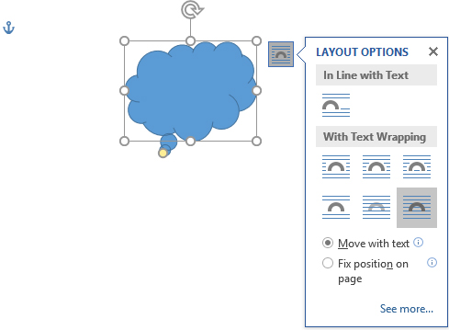
Figure 2
Choose any of the six options under the “With Text Wrapping” section, then move the shape over the text. Does the anchor disappear? If not, it is still a floating object.
Now try clicking on the inline option under “In line with Text”. Does the anchor disappear? If yes, this is now an inline object. This is where you now have to consider the text and the image together.
Below, you will see an inline shape amid the text. This is not a best practice example as line spacing is inconsistent.

Example text. Example text. Example text. Example text. Example text. Example text. Example text. Example text. Example text. Example text. Example text. Example text. Example text. Example text. Example text. Example text. Example text. Example text.
The next example is slightly better as text is above and beneath the object.

Example text. Example text. Example text. Example text. Example text. Example text. Example text. Example text. Example text. Example text. Example text. Example text.

Example text. Example text. Example text. Example text. Example text. Example text. Example text. Example text. Example text. Example text. Example text. Example text.

The last thing to consider is object alignment. This can be done by adjusting the indents on the ruler to move the shape into position.
Example text. Example text. Example text. Example text. Example text. Example text. Example text. Example text. Example text. Example text. Example text. Example text.

Example text. Example text. Example text. Example text. Example text. Example text. Example text. Example text. Example text. Example text. Example text. Example text.

Please note: the indents (on the top ruler) move when the cursor is placed on the line of the shape. Move the cursor to other lines in the document and see to the indents move.

