Alternative to Text Boxes

If you need to make text stand out with a box around it, consider doing it on the document layer.
Firstly type up the text:

This is an important notice.

This may not look like much. Highlight the text as shown below (figure 1):
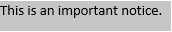
Figure 1

Then create a new Style. Go to the Home Tab, then to the Styles section and press the down arrow. Choose Create a Style (figure 2):
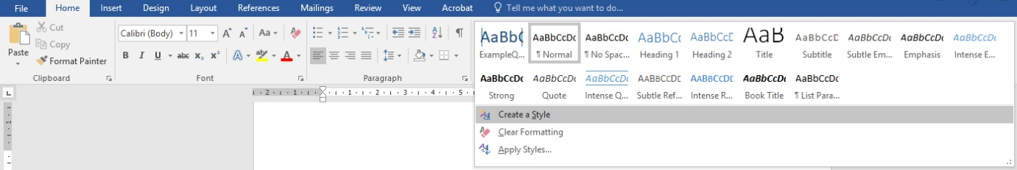
Figure 2

Give it the name “Example Quote” (figure 3), Click OK.
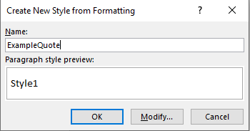
Figure 3
Change the font to size 18. Colour Blue. Centre aligned (figure 4).
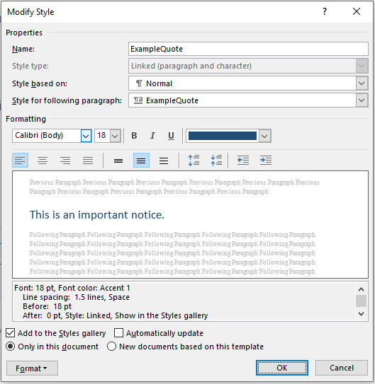
Figure 4

In the Format option (bottom left), click Paragraph (figure 5):
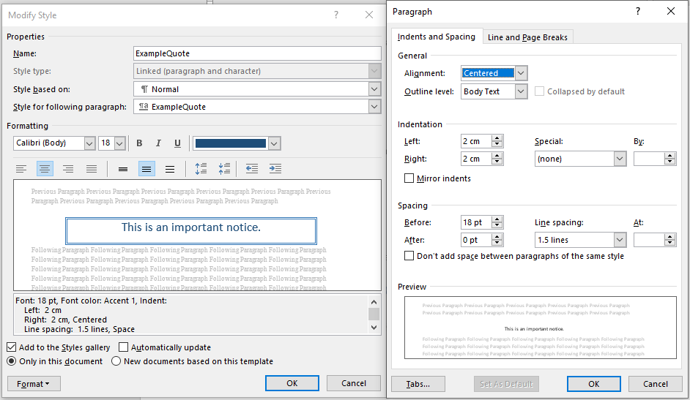
Figure 5
Choose indentations of Left 2cm, Right 2cm. Change the spacing to 18pt Before and 0pt after. Choose 1.5 Line Spacing. Click OK to the Paragraph dialogue box.
Click on the Format (bottom left) in the Modify Style dialogue box and select Border (figure 6):
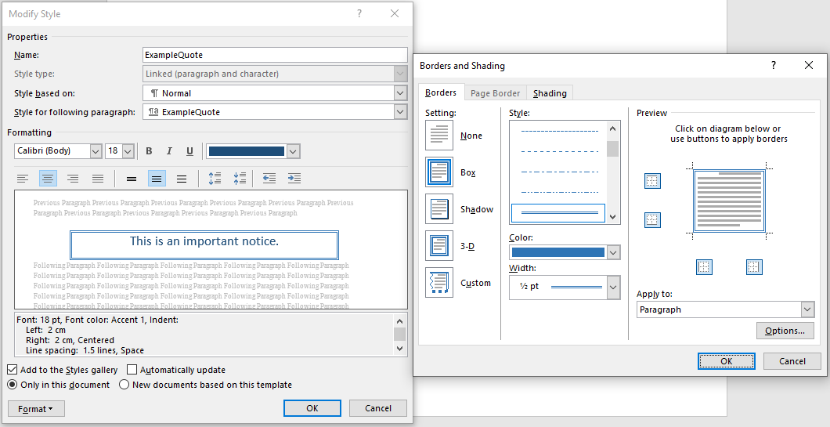
Figure 6

Choose Box on the left hand side. Choose a Style, Colour and Weight in the middle section. Then select the edges of the text this should relate to, i.e., all edges. Click OK on the Borders and Shading dialogue box.
Click OK on the Modify Style dialogue box.

Highlight the text you intend to be a quote and apply the style “Example Quote”.

This text is intended to be a quote.

This didn’t use a text box. It can be used by assistive technologies and therefore is more accessible to a wider audience. Also, when you create a style, you can use it on future documents. It can be duplicated and modified to suit your purposes.

