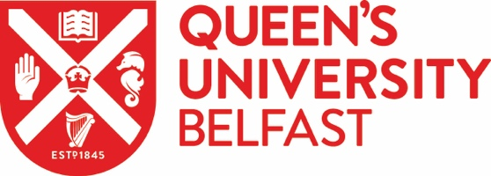

MODERN LANGUAGES CORE DISCIPLINARY RESEARCH GROUP RESEARCH SHOWCASE 2021

Friday 25 June 2021

PROGRAMME

9:30 WELCOME

9:40-10:45 PLENARY LECTURE
Child-centred art at the Mexico-U.S. Border: Ethical Questions and Imaginative Possibilities
Professor Nuala Finnegan (UC Cork)
Chair: Karol Valderrama-Burgos

11:00-12:00 Lived Experience round-table
Ros Silvester and Steven Wilson with Kathryn Nelson and Jordan McCullough

12:00-13:00 PhD Flashtalks
Chair: Ricki O’Rawe

LUNCH BREAK

14:00-14:30 2020-21, a research initiation retrospective
Chair: Tori Holmes

14:40-15:30 Languages: research and policy
Leanne Henderson and Frances Kane
Chair: Merryn Davies-Deacon

15:50-16:30 Critical interactions
Dominique Jeannerod with Ashley Harris and Ciara Gorman
Chair: Maeve McCusker

16:30-17:00 Younger voices round table
Led by PGR students with final reflection from Professor Finnegan

Colleagues are warmly invited to attend any or all of the sessions. The Research Showcase will run through TEAMS. Please direct queries to Gabriel Sánchez Espinosa g.sanchez@qub.ac.uk

