**Oh, how the tables have turned.**

We often hear people say that 'confidence is the key to success,' or the encouragement to 'fake it till you make it.' Intrigued by these ideas, I decided to test them during my simulated interview. Even though I tried to look composed, inside, I was a bundle of nerves, plagued by self-doubt and overthinking and questioning if I came across as a competent teacher. The pressure was real, evident in my nervousness and unexpected perspiration – a surprising intensity for what was, in reality, a mock interview.

Reflecting on this nerve-wracking experience using Gibbs Reflective Cycle (1988) [1] I delved into the various aspects of the situation, allowing for a comprehensive evaluation. This evaluation not only served as a means to understand my reactions during the simulated interview but also proved invaluable in preparing for what lies ahead: my upcoming PGCE interview.

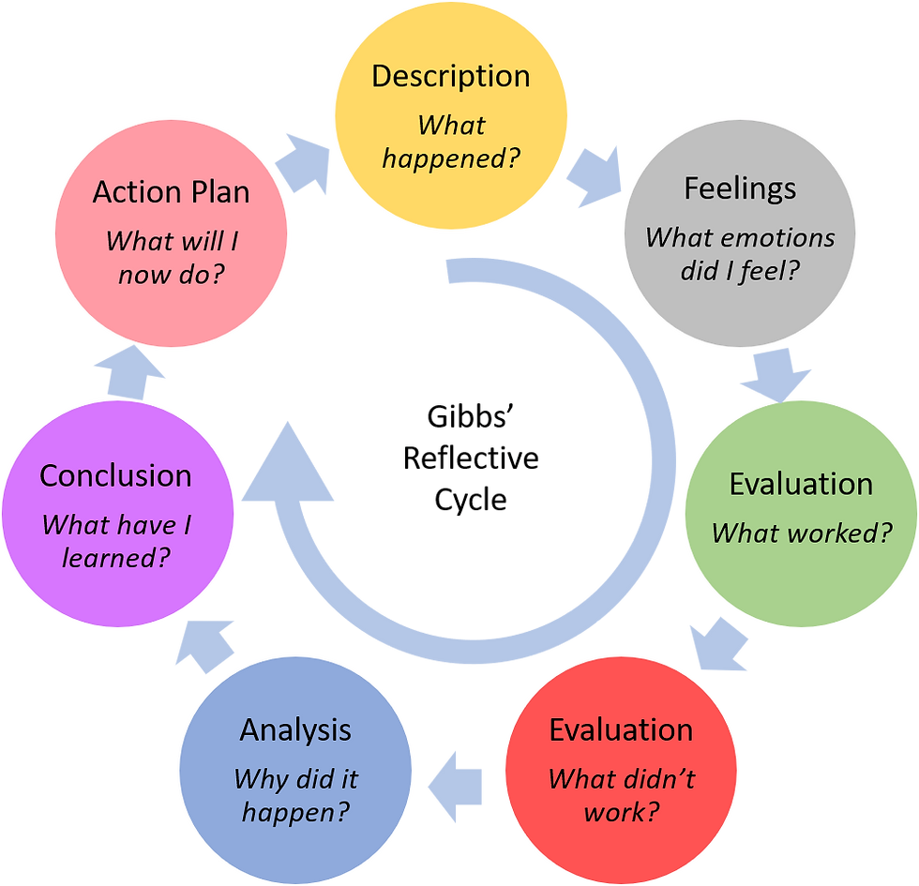

I entered the room with a smile on my face, perhaps a tad too eager. However, I couldn't help but wonder why I was grinning, considering the rain had left me drenched, my hair and outfit clinging to my skin. Despite my attempt to present myself at my best, it seemed my personality would need to compensate for the waterlogged appearance.

What made me feel a bit more comfortable was the familiar faces on the interview panel and my lecturers had thoughtfully equipped me with potential questions and interview preparation tips. Despite the setting being amongst my classmates, I decided to treat it as seriously as a genuine interview. After all, it was an invaluable opportunity to gain experience and ready myself for future endeavours.

Yet, a lingering concern nestled in the recesses of my mind. It wasn't just about facing an interview that day, there was the added responsibility of assuming a role on the interview panel. This fact loomed large in my preparations, claiming a substantial chunk of my time. Our group, recognizing the significance of our collective role, devised a strategy wherein each of us would contribute two questions. My contribution was a meticulous crafting of four questions, from which, as a team, we sifted and selected the most relevant pair. Despite my proactive approach in generating questions tailored to each interviewee's role, a stark realization hit me during the process. I found myself inadequately prepared for the follow-up inquiries, those crucial questions that should have naturally arisen when the candidates' initial responses fell short. This unexpected gap in my preparation served as a valuable lesson, highlighting the need for a more comprehensive and anticipatory approach to ensure a seamless and insightful interview experience.

Before the interview, and with all of this in mind, it was time to dive into preparation. While I already had an initial idea of what needed attention, a new terminology, STAR, emerged during our online lectures. For those unfamiliar, STAR stands for 'Situation, Task, Action, and Result.' [2] This approach proved invaluable in organizing my thoughts for the simulated interviews, ensuring a structured and comprehensive response.

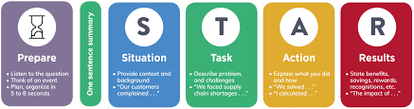

With this methodology in mind, I sat down to draft questions for fellow interviewees and formulated answers for potential questions directed at me. I transferred these onto study cards, feeling well-prepared and ready to face the challenges ahead.

Many of those around me appeared unbothered about the impending interview, opting to play it by ear. In contrast, I was keen on approaching it with a more serious mindset. My goal was to extract as much value as possible and thoroughly prepare for the actual interview. However, upon reflection, I recognized that I, too, wasn't fully prepared.

Being an applicant for the position of a primary school teacher, the prospect of memorizing the entire school syllabus proved challenging. Each attempt to commit it to memory seemed futile, and my responses to anticipated questions were rather basic, lacking the depth required to impress the interview panel. Despite possessing the necessary skills and qualities of a teacher, my knowledge of the school and its policies was insufficient.

Adding to my worries, I felt a heightened sense of nervousness about interviewing my peers. The responsibility felt daunting and seemed overwhelming, and I lacked the confidence to navigate this aspect of the process effectively.

The awaited day arrived, and I found myself making my way to the interview room. Upon entering, everyone seemed at ease, engaged in light conversations without a care in the world. Yet, despite the relaxed atmosphere, nerves gripped me. I joined my assigned group, and as we brought the first interviewee outside to finalize their questions, I couldn't help but feel a growing sense of anxiety.

Listening to others' questions heightened my unease; theirs seemed detailed and profound, contrasting with my own which felt somewhat basic and generic. This intensified my nervousness for the impending interviews. I had previously hesitated to take on the role of chairperson, and now I regretted that decision. Despite knowing the members of the panel, I found myself lacking the confidence to guide the interviewee into the room and lead the entire interview. Sophie and Lily adeptly took turns as chairpersons, showcasing their competence.

As we rotated through interviews, each lasting around 10 minutes, my apprehensions persisted. The process involved showing the interviewee out, followed by a group discussion to provide feedback and complete feedback forms. In constructing my feedback, I aimed to balance positive affirmations with constructive criticism, offering a well-rounded evaluation.

The simulated interviews proved to be an exceptionally positive and enriching experience, offering me valuable insights that have significantly contributed to my personal and professional growth. Upon reflection, the process has been instrumental in identifying areas that demand further attention and preparation, crucial for navigating the challenges of future interviews. As aptly stated, "Reflection as a process seems to lie somewhere around the notion of learning and thinking. We reflect to learn something, or we learn as a result of reflecting."[3] My role on the interview panel involved meticulous preparation, wherein I familiarized myself with the job descriptions of each interviewee in advance. This proactive approach allowed me to tailor questions based on the specific learning outcomes associated with their respective roles. It was an effective strategy for assessing candidates' knowledge and suitability for the positions they aspired to fill. However, the same level of preparation did not extend to my own job application. Although I had learned the job description, my focus inadvertently gravitated more towards anticipating potential questions rather than delving deep into the intricacies of the role. Consequently, when prompted about my own application, I found myself momentarily faltering. The interviewers had to guide me through the process of developing a more robust and comprehensive response.

The simulated interviews turned out to be a great place to develop essential soft skills, particularly teamwork and communication. I came to realize the critical role that effective communication and seamless collaboration play in ensuring the smooth operation of an interview panel. These skills, undoubtedly, are transferable to a broader professional context and underscore the significance of honing them for success in future endeavours.

Furthermore, the experience delivered a tangible boost to my confidence, especially in the context of interacting with others within a professional setting. While the simulated nature of the exercise allowed for a certain level of comfort, the gravity of the scenarios posed during the interviews prompted serious consideration of how I would approach actual job interviews, particularly within the realm of teaching.

The imminent transition to applying and interviewing for graduate roles became palpably real through this exercise, prompting me to recognize the necessity of approaching this process with the seriousness it demands. As the prospect of leaving Queens and embarking on a broader professional journey loom, the realization can be intimidating. However, the robust and well-rounded preparation received during my academic adventure at Queens has imbued me with a sense of readiness for the challenges that lie ahead.

Exploring the interviews from both an interviewee and interviewer perspective has been transformative, shifting my perception and instilling the confidence that interviewers are, fundamentally, ordinary individuals. This newfound perspective has substantially alleviated my nervousness and apprehension when contemplating real-life interviews.

In summation, the simulated interviews have been an enlightening journey, exposing me to a multifaceted understanding of my strengths and weaknesses within the interview setting. I wholeheartedly welcome and appreciate all feedback garnered from this experience, recognizing its potential to be a valuable asset in refining my approach during future job interviews. The lessons learned and skills developed through this simulation have undoubtedly positioned me well for the dynamic and competitive landscape of professional interviews that await.

**Bibliography:**

* *Gibbs’ Reflective Cycle,* (11 November, 2020) < <https://www.ed.ac.uk/reflection/reflectors-toolkit/reflecting-on-experience/gibbs-reflective-cycle> > [Accessed 1st March 2024}
* *The STAR Method,* National Careers Service < <https://nationalcareers.service.gov.uk/careers-advice/interview-advice/the-star-method> > {Accessed 1st March 2024}
* Jenny Moon, *Reflection in Learning and professional development* < <https://www.researchgate.net/publication/247374308_Reflection_in_learning_professional_development#:~:text=understanding%20of%20phenomena.-,Moon%20(2013)%20states%2C%20%22%20%27reflection%2C%27%20as,%22%20(p.%20>... > {Accessed 2nd March 2024}
* Lucy Baxter, (2023), ‘Interview Skills’ *AEL3001* < <https://canvas.qub.ac.uk/courses/24548/files/4118583?module_item_id=1038317> > [Accessed 18th February 2024]
* (2024), *Carrickfergus Home Academy,* < <https://www.carrickfergus.academy> > [Accessed 24th January 2024]
* (2024), *interview tips,* < <https://nationalcareers.service.gov.uk/careers-advice/interview-advice/interview-advice> > [Accessed 25th January 2024]
* *The STAR Method* < <https://capd.mit.edu/resources/the-star-method-for-behavioral-interviews/> > (Massachusetts Institute of Technology, Cambridge, MA 02139) [Accessed 12th February 2024]
* Jonathan Gibbon (2019) *Gibbs Reflective Cycle,* < <https://www.pmsystems.co.uk/post/we-do-not-learn-from-experience-we-learn-from-reflecting-on-experience> > [Accessed 11th January 2024]

1. *Gibbs’ Reflective Cycle,* (11 November, 2020) < <https://www.ed.ac.uk/reflection/reflectors-toolkit/reflecting-on-experience/gibbs-reflective-cycle> > [Accessed 1st March 2024}
2. *The STAR Method,* National Careers Service < <https://nationalcareers.service.gov.uk/careers-advice/interview-advice/the-star-method> > {Accessed 1st March 2024}
3. Jenny Moon, *Reflection in Learning and professional development* < <https://www.researchgate.net/publication/247374308_Reflection_in_learning_professional_development#:~:text=understanding%20of%20phenomena.-,Moon%20(2013)%20states%2C%20%22%20%27reflection%2C%27%20as,%22%20(p.%20>... > {Accessed 2nd March 2024}