Studios for Sunday Morning Live

Loop Studios

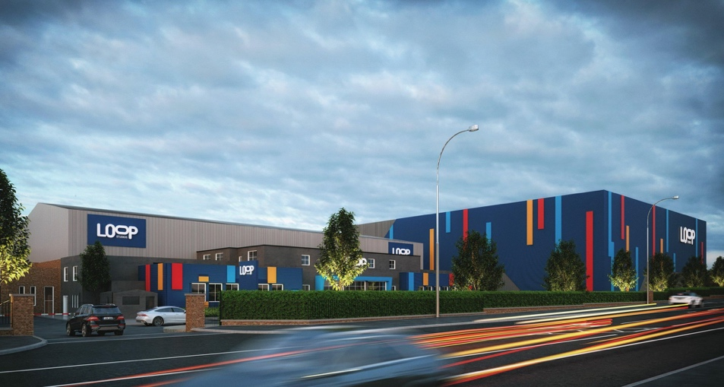

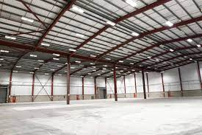

- Loop Studios is an independent film studio based in Belfast, Northern Ireland. Housed in a former factory and set up in 2013.
- The site comprises of 3 stages as well as 2 workshops and office space.
- Loop Studios offers three stages ranging in size from 20,000sq ft to 38,000 sq ft with heights of up to 39 ft, providing flexible space for TV and film productions. There are also two workshops of 3,800 sq ft and 8,183 sq ft.
- Studio C ‘Donard’ – Studio Space:20,000 sq ft & eaves height 32 ft rising to 37 ft at the mid-point could be used for the production of Sunday Morning Live.
- 468-472 Castlereagh Rd, Belfast BT5 6RG

Acorn Studios

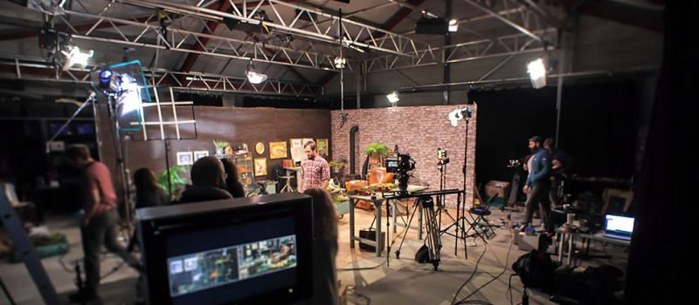

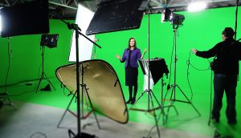

- Situated in Belfast’s Queens Quarter. The renovated for purpose stables incorporates: a 1600 ft2 drive in studio with 270-degree Green Screen and Blacks with a 20 x 26ft lighting grid at 16 ft. with multichannel DMX dimming.
- Studio consists of a 140 Square Metres of Floor space, 270 Degree Black Out Drapes, Green Screen Facilities, and a fully adjustable Lighting Truss.
- With a large range of: Cameras and Equipment, high end Postproduction Suite, Studio Facilities, Kitchen, Make Up Suite and Production Offices we are capable of providing a full-service package to all sizes of productions.
- 13 Fitzwilliam Street Belfast, BT9 6AW
Queen’s Film Studio

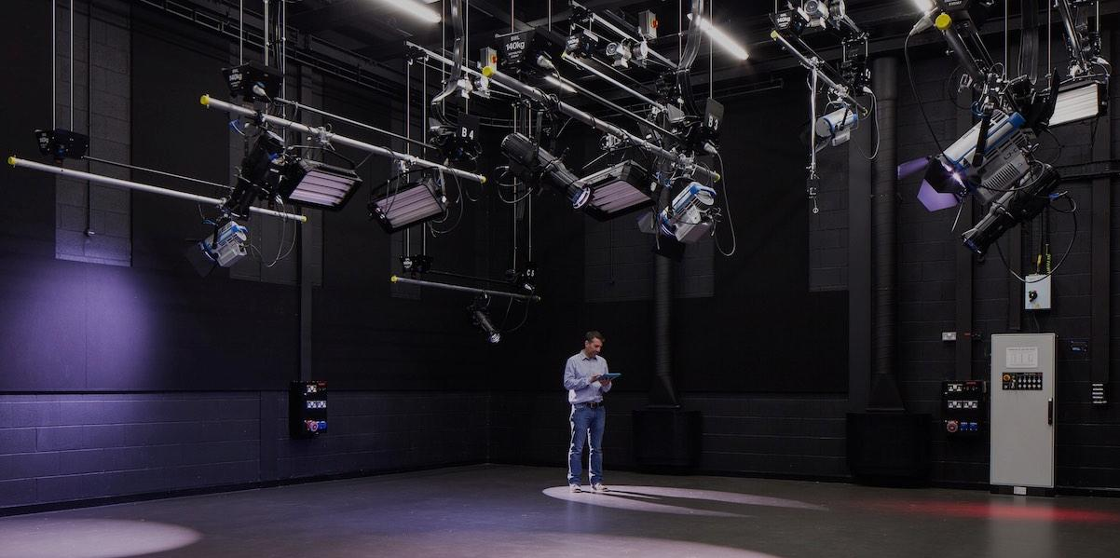

- The studio is approximately 13m L x 12m W x 13m H and is sound insulated to broadcast specifications.
- The lighting grid which covers the entire floor plan, features custom made Doughty hoists with state of the art broadcast approved LED and cool running lighting systems from Arri and others. A full DMX lighting control system has also been installed. This system is rooted through a programmable ETC lighting control desk.
- This sustainable design approach makes the studio one of the most energy efficient studios on the island of Ireland. Energy consumption is less than 10% of a conventional studio with comparable light output and fittings.
- 20 University Square Belfast, BT7 1PB

Belfast Studio Rental

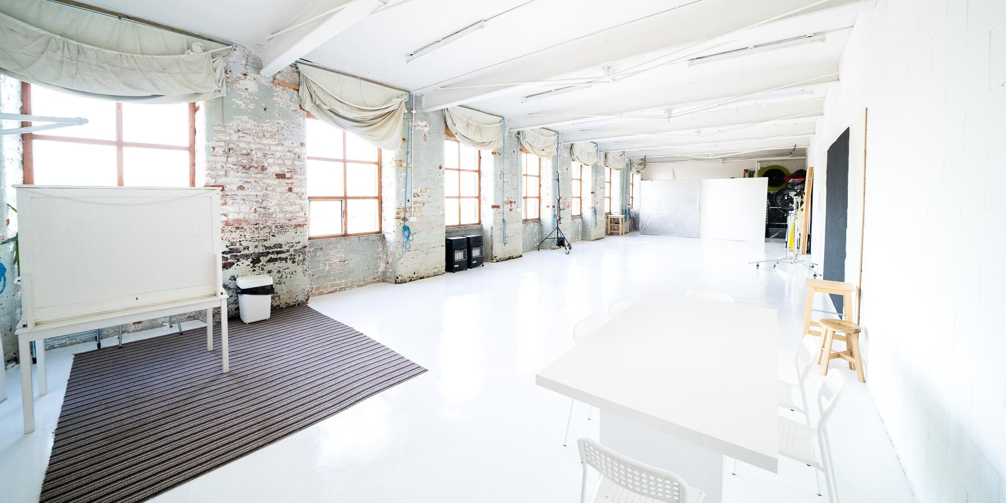

- Belfast Studio Rental was created out of the need for a modern contemporary shooting space in Belfast. Reminiscent of a New York City loft, it has high ceiling and aged brickwork
- Belfast Studio Rental is a large 1300 sq.ft. daylight studio space, 5 minutes from downtown Belfast.
- The studio comes as an empty space and you can add gear as you need it.
- 81 Springfield Rd, Belfast BT12 7AE

Catchlight Studios
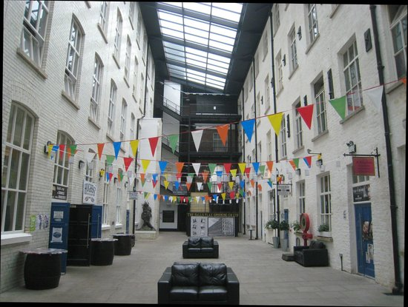
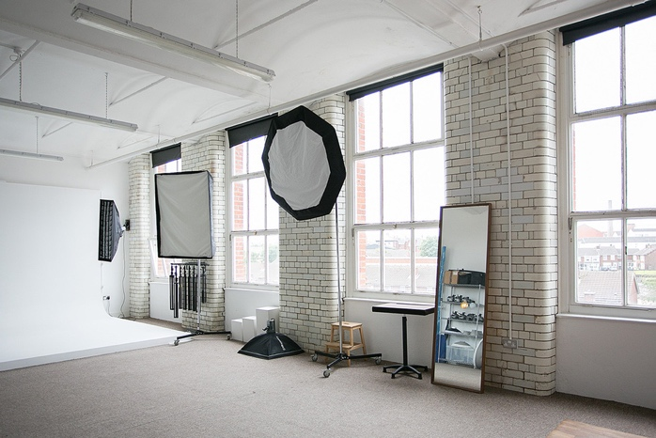

- Catchlight is an established custom built 1000sq ft Studio in Conway Mill, Belfast.
- Daylight studio (6 very large south facing windows) with anti-reflective blackout blinds.
- Full rental experience including Elinchrom Studio Lights (9 Heads) and numerous light-shaping tools (soft-boxes, octas, beauty dishes etc).
- Conway Street, Falls Road, Belfast, BT13 2DE

