Potential SML Presenters

Kaye Adams
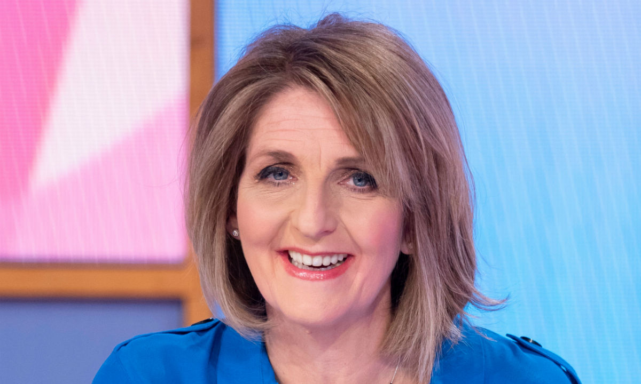

- Kaye Adams is best known for being the presenter and host of ITV's daytime show Loose Women. She was born in Grangemouth, Stirlingshire, Scotland. Previous to Loose Women, Kaye was the host of STV's Scottish Women which ran for six years and won a number of Awards. It still ranks as one of the most successful STV has ever produced, marking the start of Kaye's career as a talk show host.

https://www.speakoutuk.com/speaker-index.html?speakerid=60&speakertypeid=119

John Leslie
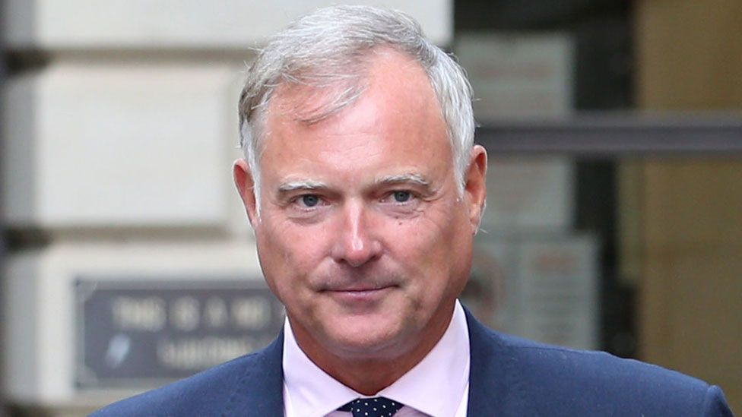

- John Leslie, broadcaster, and presenter, at 6ft 5in tall with a distinctive Edinburgh accent and large personality is hard to miss and was probably always destined for a career in television and on the stage.

https://www.speakoutuk.com/speaker-index.html?speakerid=22&speakertypeid=119

Fred MacAulay

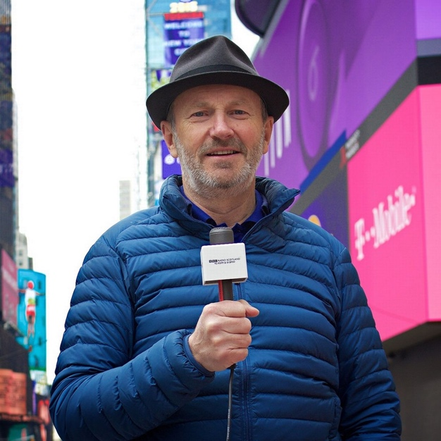

- Fred MacAulay is a household name in Scotland. He is a regular presenter on radio with his own show MacAulay & Co and is often seen on our screens as a guest panellist on Dara O Briain's 'Mock The Week', Stephen Fry's 'QI' and Have I Got News For You.
- He was also the first mainstream Scottish comedian to compete at London's Comedy Store. Fred is also a bit of an internet hit with many of his TV appearances now being shown on YouTube, clocking up thousands of views.

https://www.speakoutuk.com/speaker-index.html?speakerid=49&speakertypeid=119

Amanda Byram

- Amanda Byram is one of Ireland's biggest exports. She started her career as a model at the tender age of 16 and from there went on to take the TV world by storm.
- Amanda is to present brand new entertainment show Don't Stop Me Now - a rapid-fire, high-stakes talent contest where getting rid of the dross is as much fun as discovering moments of true talent and entertainment.

https://www.speakoutuk.com/speaker-index.html?speakerid=96&speakertypeid=119

Jemel Akeem

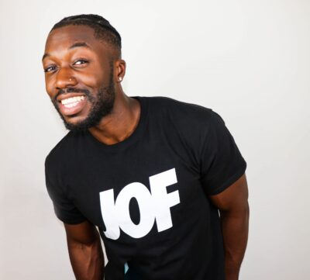

- Jemel One Five is a YouTube star and presenter hailing from Bristol, UK. With his infectious humour, excitable energy and down-to-earth personality, Jemel has a natural ability to entertain and make people laugh. With 237K+ subscribers and over 8 million views his YouTube channel is going from strength to strength.

https://www.unitedagents.co.uk/jemel-akeem-jemel-one-five#presenting

Alex Brooker

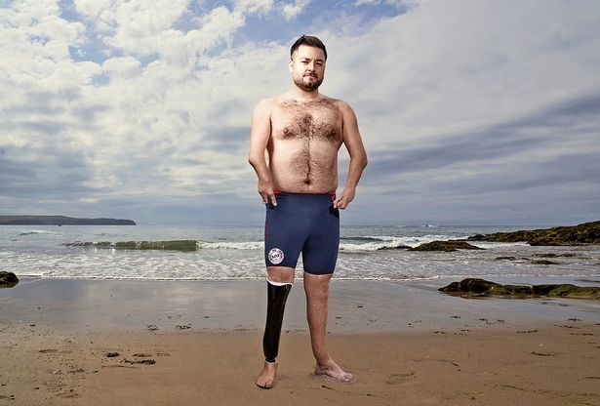

- Alex Brooker is an English journalist, presenter and comedian best known for his television work with Channel 4. Since 2012, Brooker has co-hosted The Last Leg, a Channel 4 panel show with Adam Hills and Josh Widdicombe as well as co-presenting Channel 4 ski jumping show The Jump with Davina McCall in 2014

https://www.independenttalent.com/alex-brooker/

Llyod Griffith
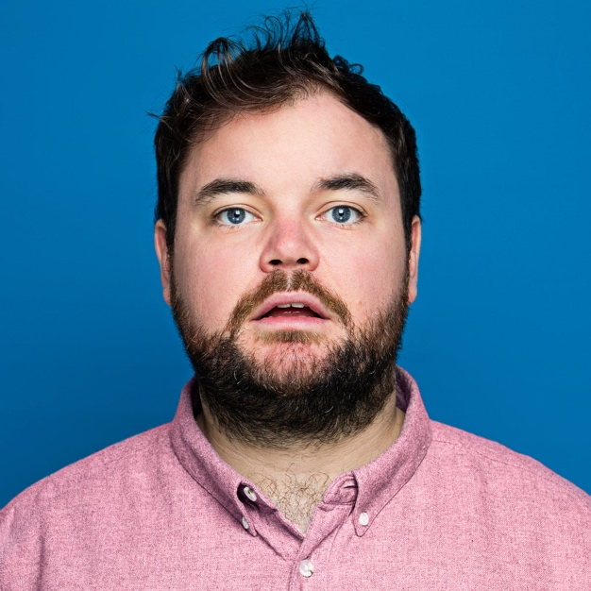

- Lloyd Griffith is a comedian, presenter, actor and a choirboy from Grimsby, England.Lloyd co-hosted SOCCER AM every Saturday morning for 2 years on Sky One/Sky Sports alongside John Fendley and Jimmy Bullard.
- He was one of the hosts of comedy action game show FLINCH with Desiree Burch and Seann Walsh for Netflix and fronted his own critically acclaimed BBC documentary CAN YOU BEAT THE BOOKIES.

https://www.unitedagents.co.uk/lloyd-griffith#presenting

Shareefa J
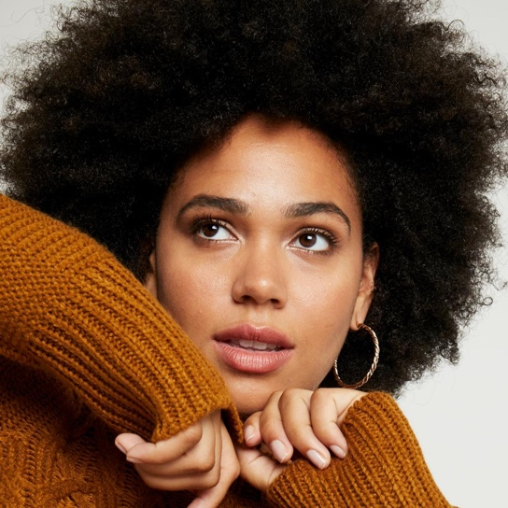

- Shareefa J is a London based presenter and plus-size model with a background in musical theatre, she is at the forefront of promoting equality and mental health awareness.
- She uses her platform to discuss many topics including Black Lives Matter, LQBTQIA+ topics, plant- based eco-friendly living, fitness, adult ADHD, women’s health and eating disorders. Shareefa is an ambassador for the UK based mental health charity CALM and works closely with them to help raise awareness and destigmatise the conversation around suicide.

https://www.starnow.co.uk/shareefaj/

Leah Boleto
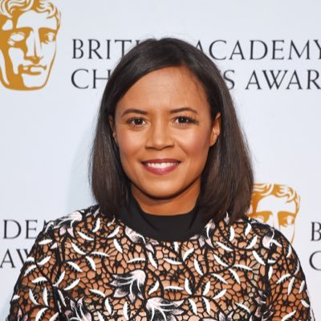

- Leah Boleto (née Gooding) is a presenter and journalist from Manchester, having worked on many of the BBC's most watched and listened to programmes. Most recently she has co-hosted BBC 5Live Drive, presented for BBC Sport, Stargazing Live and Autumnwatch and is now a reporter and presenter for 5 News on Channel 5.
- She is best known by millions of children as a presenter on CBBC's Newsround, the BBC's flagship news show for young people and for over 10 years

Lawrence D'Silva

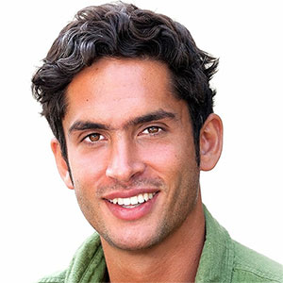

- Lawrence D'Silva is a presenter, filmmaker and natural world specialist. From working as a safari guide in southern Africa to renewable energy projects and environmental investment in the UK, nature has always been his passion. He aims to entertain and inspire action and debate through film.

http://www.talent4media.com/talent/lawrence-dsilva/

Sophie Morgan

- Sophie Morgan is an award-winning disability advocate, TV presenter & social entrepreneur. After being paralysed in a car crash when she was 18 years old, she is one of the only television presenters with a disability in the world.
- Voted as one of the Top 10 most influential people with a disability in the UK, she is determined to channel her adversity into opportunity and she sees her challenges as a unique chance for creativity and has become the ultimate agent for change.

https://www.mcsaatchimerlin.com/talent/sophie-morgan

Fatima Manji
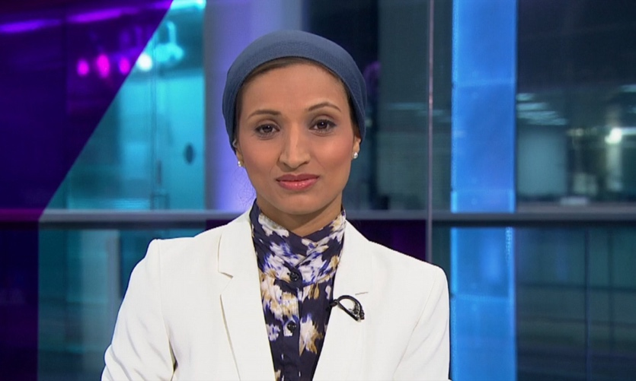

- Fatima is a British newsreader and television journalist who studied Politics at the LSE (London School of Economics), before working at the BBC as a trainee. She subsequently joined Channel 4 News, becoming the first hijab-wearing newsreader in Britain.

https://uk.linkedin.com/in/fatimamanji

Charlie Webster
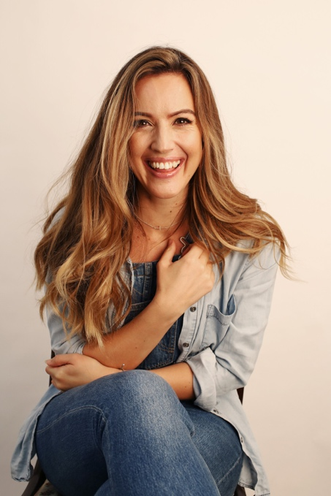

- Charlie is an experienced broadcaster, journalist, writer and documentary maker across both TV and Radio. Born in Sheffield, England, she has worked globally for major TV networks, events, and brands from the London Olympic and Paralympic Games, FIFA World Cup’s to premiere in-depth interviews ranging from superstars such as Arnold Schwarzenegger.

https://www.gordonpoole.com/talent/charlie-webster/

Alison Hammond

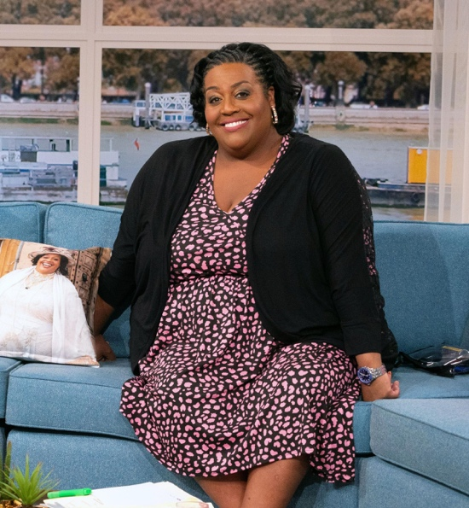

- Known for her quick wit, outrageous presenting style, and big heart, nobody gets a better interview than Alison Hammond.
Alison born in Birmingham, England, joined ITV daytime show This Morning back in 2003. In 2021 she became one of the main hosts, alongside Dermot O'Leary, presenting Friday's on the show.

- As well as being a firm family favourite on This Morning, 2021 has seen Alison as one of the judges on 'I Can See Your Voice,' a BBC Saturday night primetime entertainment show, alongside fellow judges Amanda Holden and Jimmy Carr, and host Paddy McGuinness. Alison has also had a tea-time Saturday night game show with comedian Joe Lycett - 'The Time It Takes' - and was a contestant on hit show Strictly Come Dancing.

https://www.beccabarrmanagement.co.uk/talents/8-alison-hammond

Andi Peters
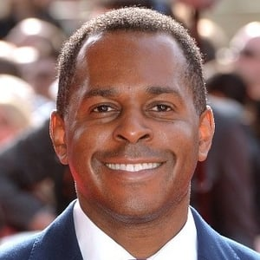

TV presenter Andi Peters has rarely been off our screens since crashing the Broom Cupboard on Children’s BBC with Edd the Duck in 1989. Popular with kids and their parents Peters took on a bigger role with the BBC as co-presenter of flagship Saturday morning show Live & Kicking, which he presented alongside Emma Forbes and John Barrowman until 1996. His final goodbye scene was voted as one of the top tear-jerking moments in TV history by Channel 4.

https://mn2s.com/booking-agency/talent-roster/andi-peters/

