Strident Pitch – Helping Hospitality

Logline
Based on these two articles below a three-part docuseries can be created focusing on the collapse and revival of the hospitality industry due to the COVID 19 pandemic.

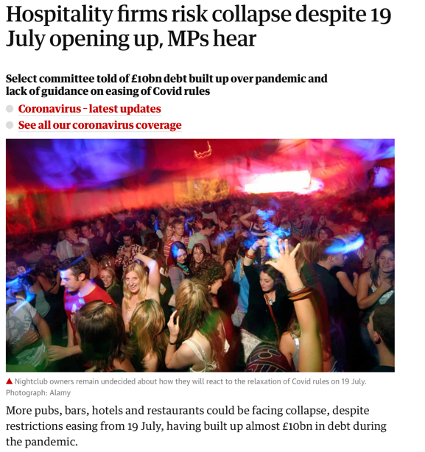
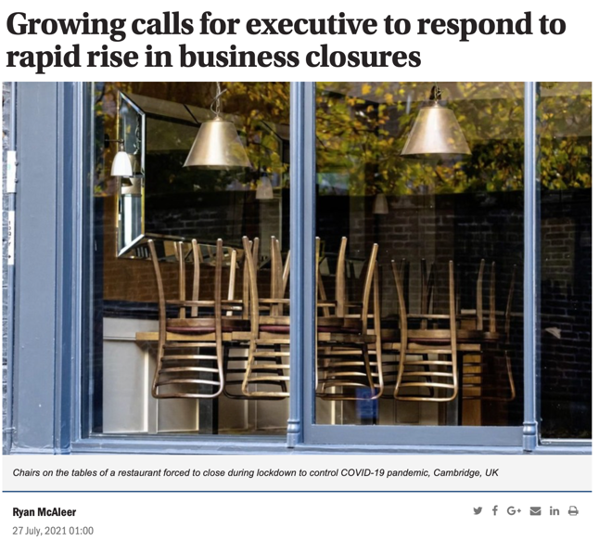

https://www.irishnews.com/business/2021/07/27/news/growing-calls-for-executive-to-respond-to-rapid-rise-in-business-closures-2399705/
https://www.irishnews.com/business/2021/07/27/news/growing-calls-for-executive-to-respond-to-rapid-rise-in-business-closures-2399705/

The Story
The show would be split into three 30 Minute episodes focusing on two hospitality businesses within Belfast. The Episode dynamic of the show creates enjoyable and watchable television as each episode will have a different focus. For example, episode one will focus on the beginning of the pandemic and the initial effects it had on the hospitality industry. The second episode will focus on the impact of the businesses reopening after the first lockdown and the measures put into place to create more business for the industry regarding the Eat Out to Help Out scheme. The episode would lead up to the second closure in October 2020. Finally, the third episode would focus on the final reopening of the hospitality industry showing the closure of businesses and the revival of others. While simultaneously providing an insight into struggles faced by Hospitality businesses. The series would end focusing on the new Northern Ireland licensing laws and what that means for both the businesses and the punters.

The Audience
The target audience for this show would be Northern Irish adults aged 18- 65 with a particular interest in both business and the hospitality industry. Similarly, this will be beneficial for the businesses focused on throughout the docuseries as with an insight into certain businesses this could provide an opportunity to help create more business that helps with negative effects faced by the industry.

